# EXAM REGISTRATION PORTAL

USE CASE DIAGRAM

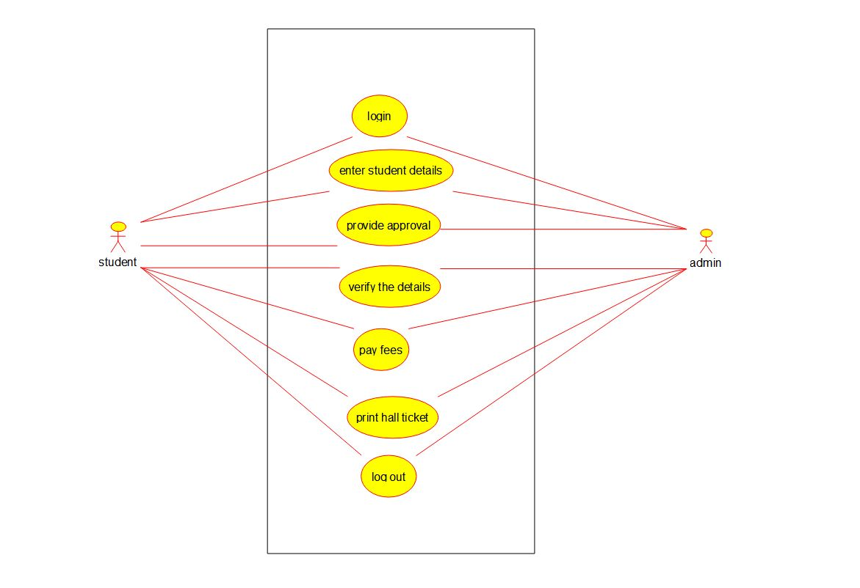

CLASS DIAGRAM

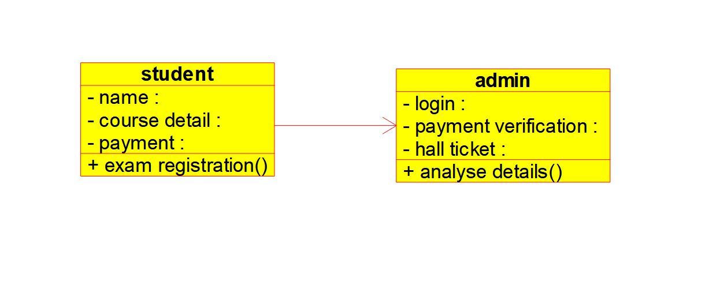

ACTIVITY DIAGRAM

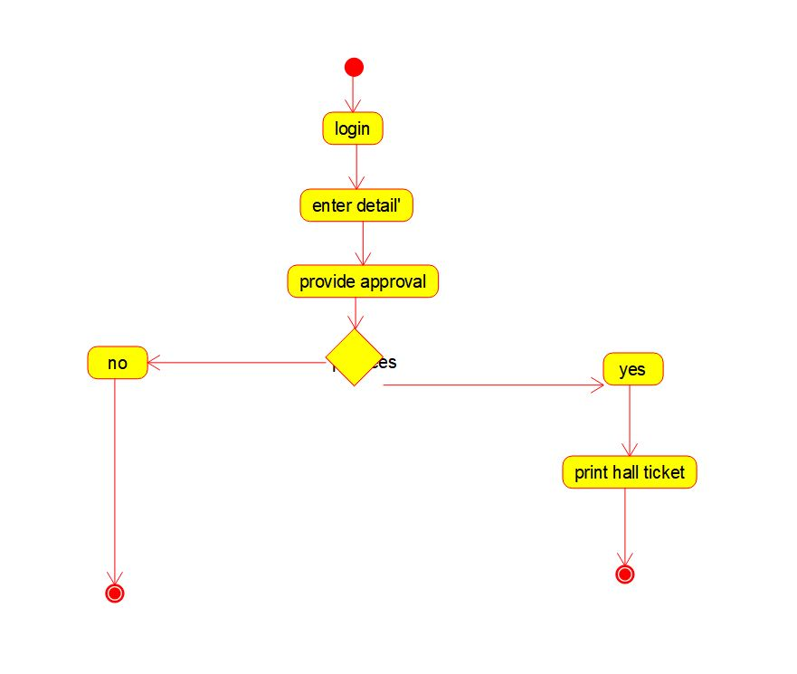

COMPONANT DIAGRAM

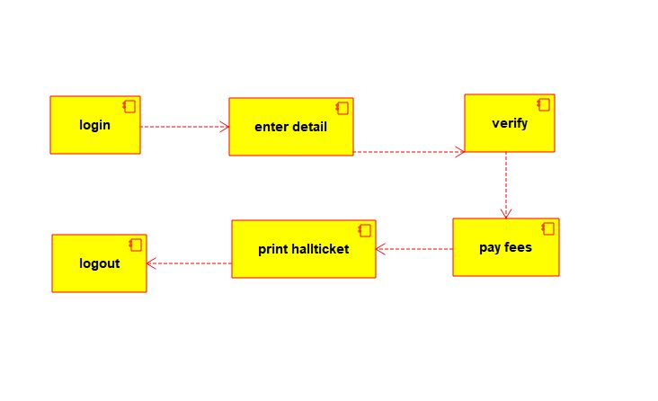

SEQENTIAL DIAGRAM

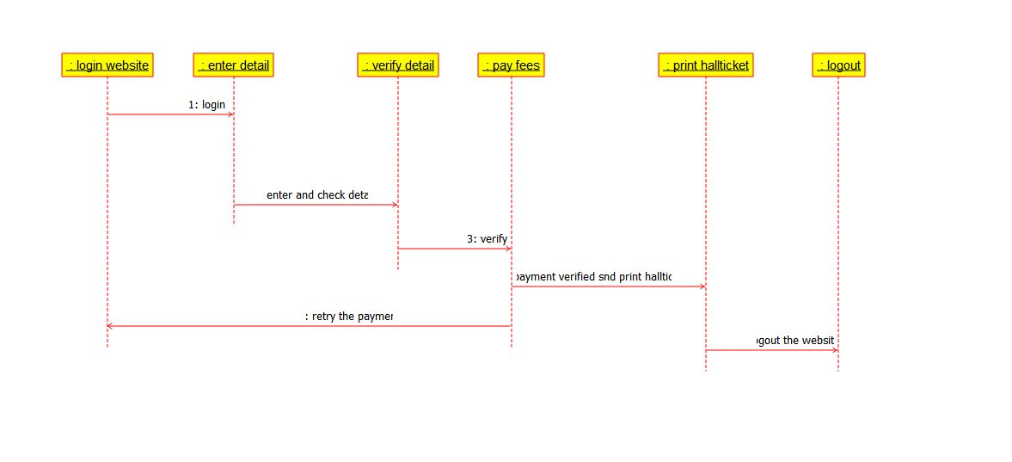

STATE DIAGRAM

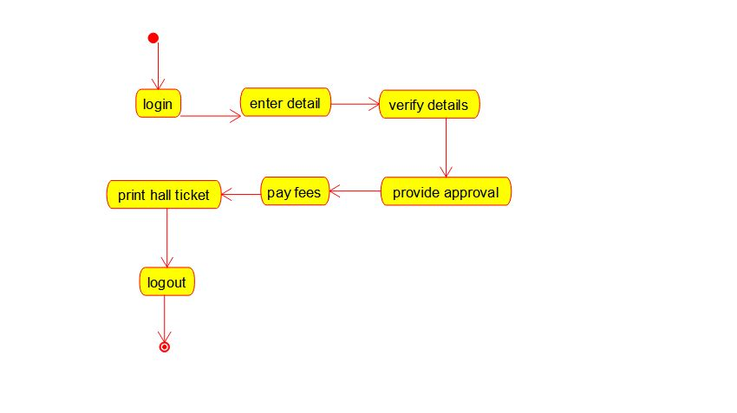

PACKAGE DIAGRAM

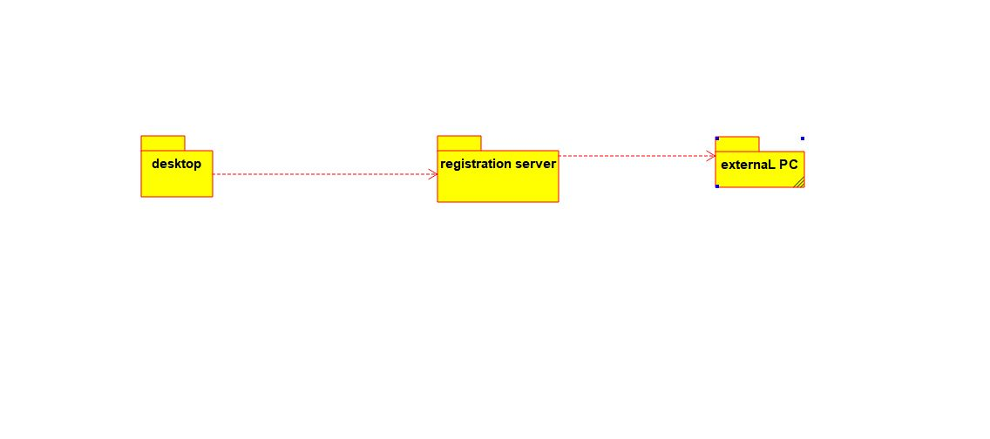

DEPLOYMENT DIAGRAM

